# Web Services

# Project Report

# Joseph Jananji

# 2195417

**The URL for the Calculator API on AWS:**

<http://webservicesvanierjoseph-env.eba-4bqnfdnx.ca-central-1.elasticbeanstalk.com/>

**Description of the Calculator API:**

This API is a Calculator on AWS which accept three parameters the first and second numbers “num1” and “num2” as integer type then the operation “operation” as string.

The accepted operation is:

As symbol: ! , ^ , % , + , - , * , /

Or as String: Factorial , Power , Modulus , Add  , Subtract , Multiply , Divide.

The parameters can be sent in GET or POST method as the user wants.

Then return the result can be sent in JSON or XML format as the user wants.

The programming language used for this API is PHP.

This API is sanitized (Prevent SQL Injection attacks and prevent XSS attacks).

**Documentation of the Calculator API:**

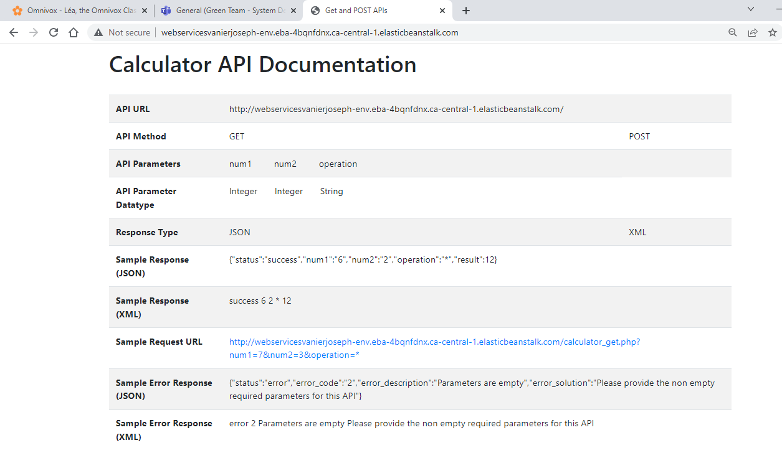

**JSON API screenshots:**

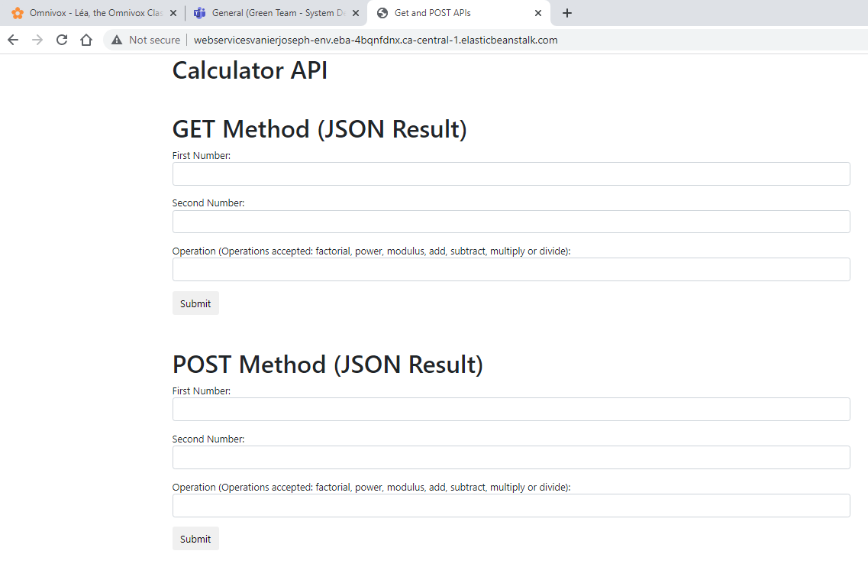

**XML API screenshot:**

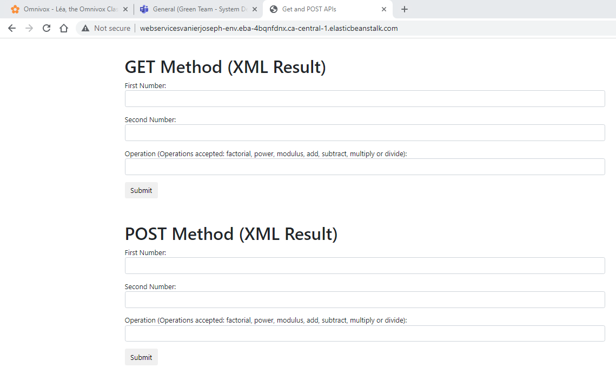

**Postman screenshot for GET:**

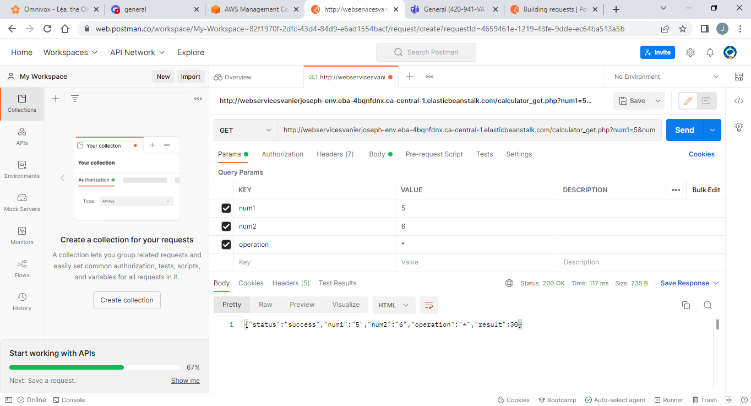

**Postman screenshot for Post:**

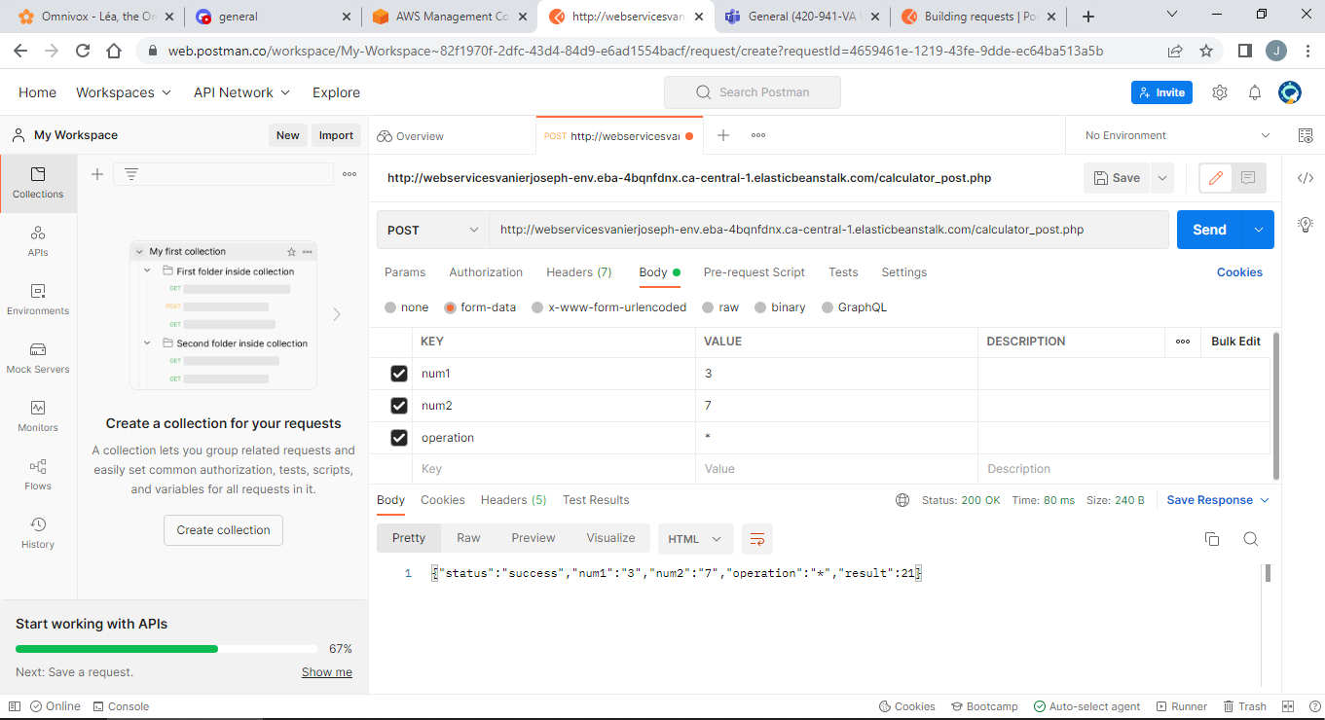

**Screenshot of the output in JSON:**

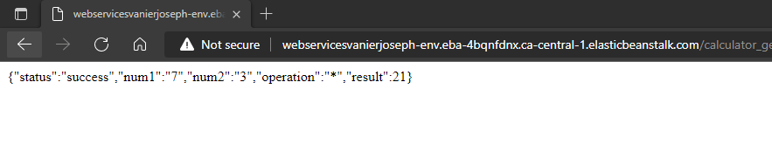

**Screenshot of the output in XML:**

